Orleans Bar Cart
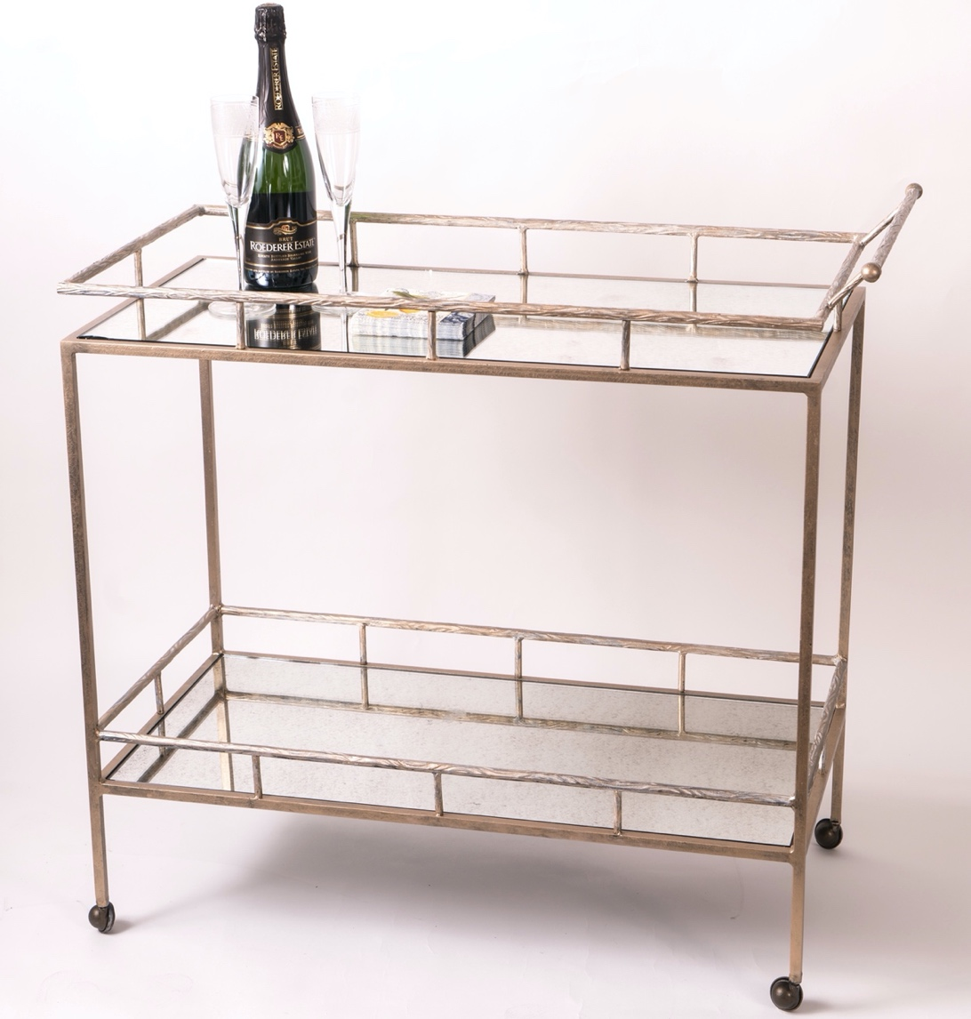
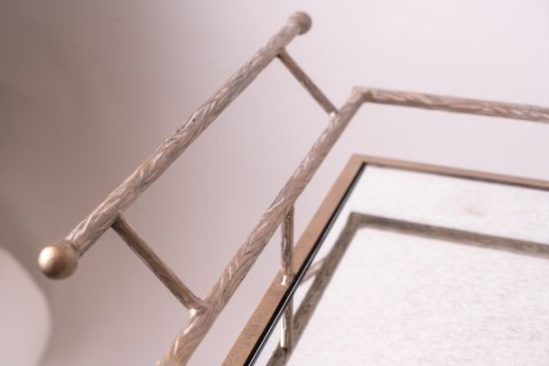

Shown in Gold Wash finish – 2 shelves antiqued mirror

