

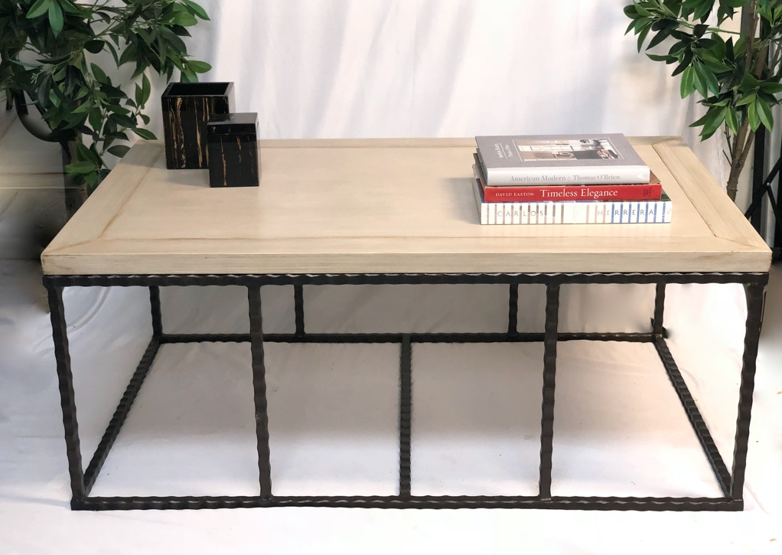

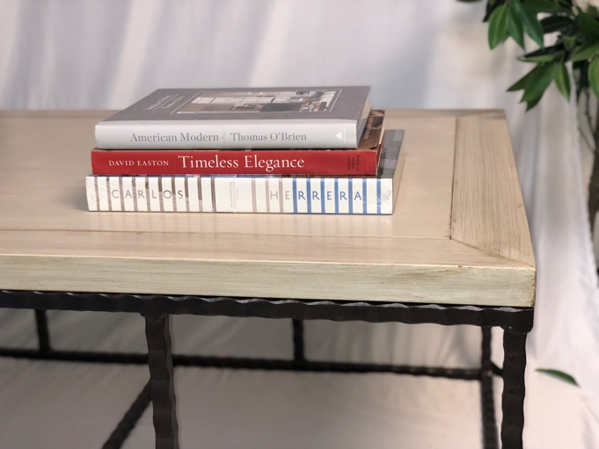

Jefferson Coffee Table

Shown 40” x 30” x 19” h

Bronze base with painted, scored wood top