CHARTRES COCKTAIL OTTOMAN
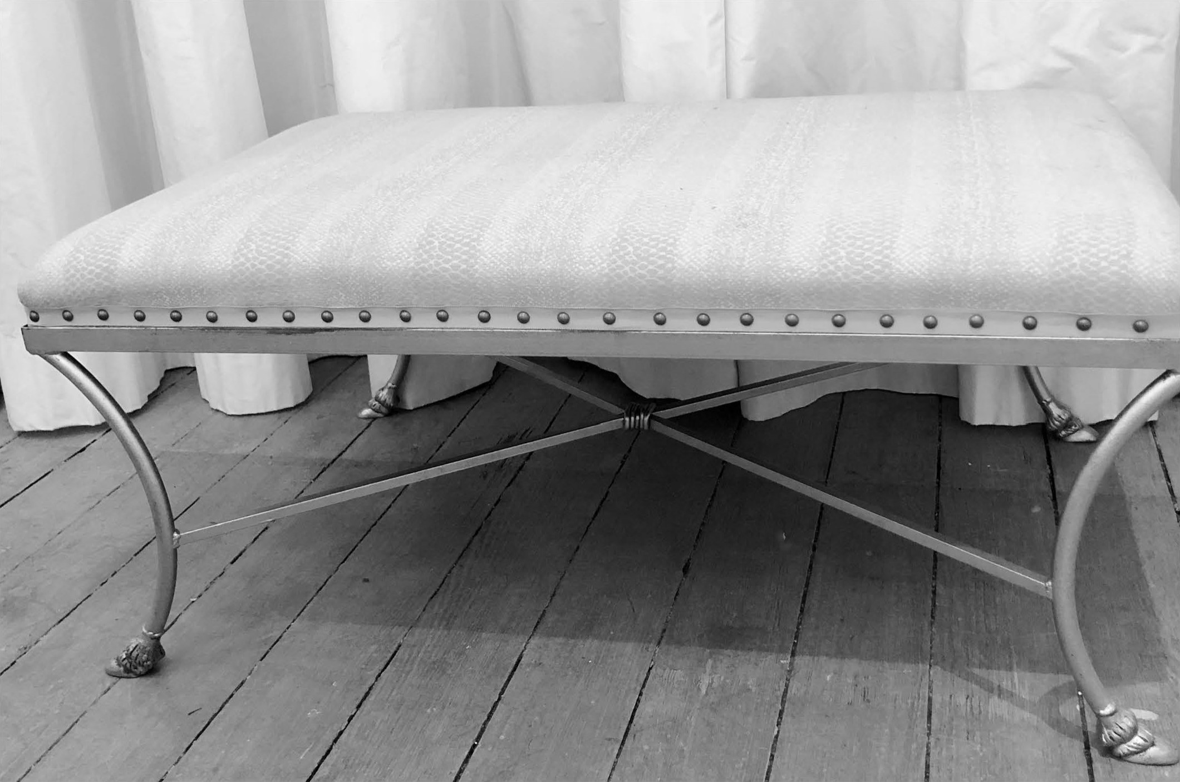
Ottoman with tape and nailhead trim
3908 Magazine St., New Orleans, LA (504) 400-9032 kafhyslater118@gmail.com kafhyslater.com

