

*Bienville Etagere*

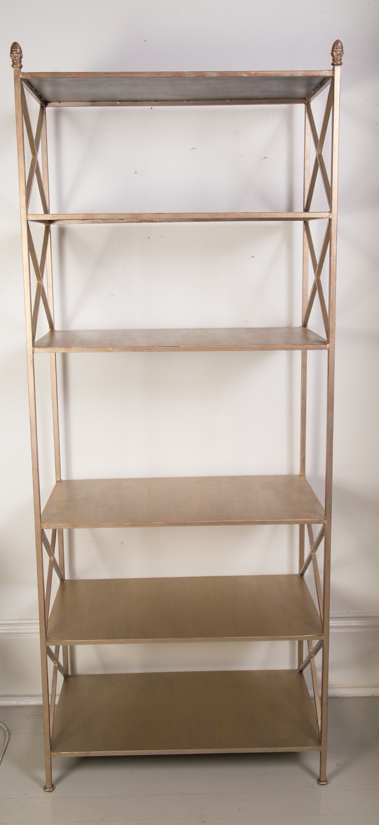 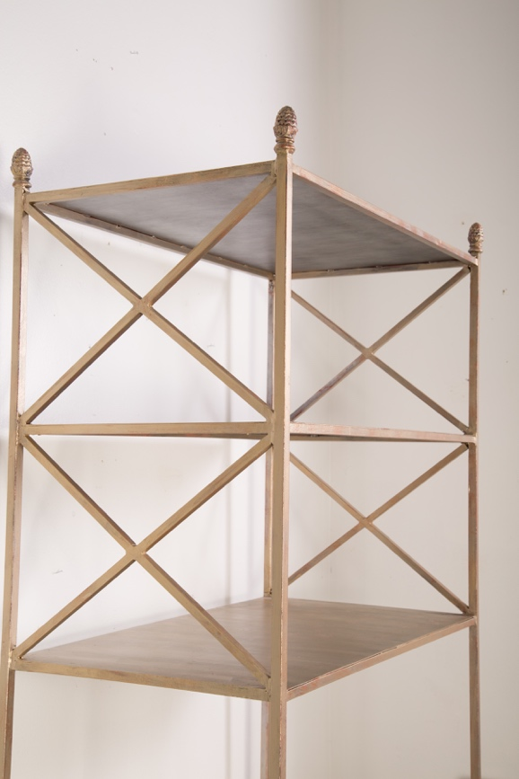

*32” x 18” x 78”h*

*Available in custom sizes and all finishes*